Table of Contents

**URM Calculation 2**

**Time Demand Analysis 3**

**Check shcedulability for task one 3**

**Check shcedulability for task two 4**

**Check shcedulability for task three 4**

**Simso result5**

**My comments on Simso result7**

**URM Calculation:**

URM = N * (2^ (1/N) - 1)

N = 3

URM = 3 * (2^ (1/3) - 1) = 0.78

U = C / T

U = (2.5 / 5) + (4.5 / 15) + (4.5 / 20) = 0.98

Now, from the calculation we can see that **U > URM**

So we need more tests to check the system Schedulability.

**Time Demand Analysis:**

Calculate the critical instant:

HYPERPERIOD (H) = LCM (PI) = 60

Check shcedulability for task one:

Task 1 { P : 5 , E : 2.5 , D : 5 , PRIORITY : 3 } .

Time provided for task 1 = 5ms

Time provided for task 1 = 2.5 + 0 = 2.5ms

**Tn < Tp** -> Task one is schedulable

Check shcedulability for task Two:

Task 1 { P : 15 , E : 4.5 , D : 15 , PRIORITY : 2 } .

Time provided for task 2 = 15ms

Time provided for task 1 = 4.5 + (15/5) * 2.5 = 12ms

**Tn < Tp** -> Task two is schedulable

Check shcedulability for task Two:

Task 1 { P : 20 , E : 3.5 , D : 20 , PRIORITY : 1 } .

Time provided for task 2 = 20ms

Time provided for task 1 = 3.5 + (20/5) * 2.5 + (20/15) * 4.5 = 22.5ms

**Tn > Tp** -> Task two is not schedulable

**SIMSO Results:**

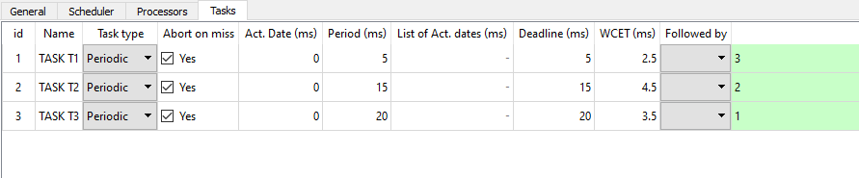 **Tasks Parameters:**

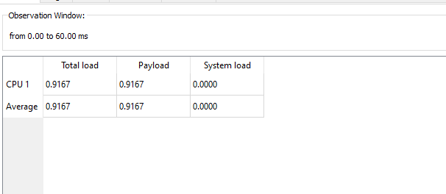**CPU load:**

**Time Line:**

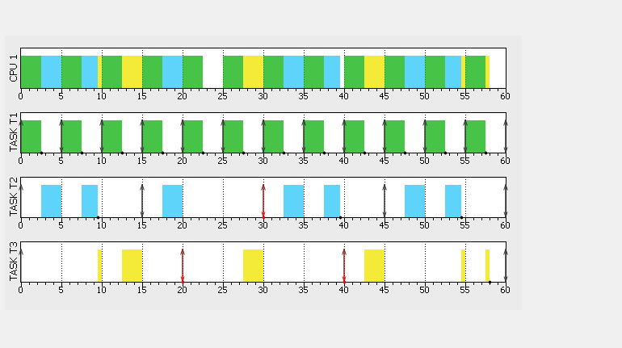

**Comments on SIMSO results:**

Task three missed its deadline hence the **system is not schedulable**.

CPU LOAD IS HIGH.